Software Requirements Specification
for
Electronic Field Input System to a Fish Survey Database
Version 1.0
Prepared by Stacy Carlson, Thomas Flores, and Ralph Parkison
Team 5
October 11, 2014
Table of Contents
Table of Contents i
Revision History ii
1. Introduction 1
1.1 Purpose 1
1.2 Document Conventions 1
1.3 Intended Audience and Reading Suggestions 1
1.4 Project Scope 1
1.5 References 1
2. Overall Description 2
2.1 Product Perspective 2
2.2 Product Features 2
2.3 User Classes and Characteristics 3
2.4 Operating Environment 3
2.5 Design and Implementation Constraints 3
2.6 User Documentation 3
2.7 Assumptions and Dependencies 3
3. System Features 3
3.1 Welcome Screen User Interface 3
3.2 General Work Information Entry User Interface 4
3.3 Angler Creel Survey Entry User Interface 4
3.4 Upload Data to Fish Survey Database 5
3.5 Download Data from Fish Survey Database 6
4. External Interface Requirements 6
4.1 User Interfaces 6
4.2 Hardware Interfaces 7
4.3 Software Interfaces 7
4.4 Communications Interfaces 7
5. Other Nonfunctional Requirements 7
5.1 Performance Requirements 7
5.2 Security Requirements 7
5.3 Software Quality Attributes 8
6. Other Requirements 8
7. Deliverables 8
Appendix A: Glossary 8
Appendix B: User Interfaces 9
Appendix C: User Stories 15
Appendix D: Legacy Forms 20
Appendix E: Actual Timeline And Distribution of Work 21
Appendix F: Issue List 25

Revision History
Name | Date | Reason For Changes | Version
Stacy Carlson, Thomas Flores, and Ralph Parkison | 10/11/14 | Initial Draft | 1.0 draft 1
Stacy Carlson, Thomas Flores, and Ralph Parkison | 11/7/14 | Revisions to Satisfy Senior Project Requirements | 1.0 draft 2
Stacy Carlson, Thomas Flores, and Ralph Parkison | 3/5/14 | Revisions to Reflect Delivered Product | 1.0 draft 3

Introduction

Purpose
This SRS describes the software functional and nonfunctional requirements for release 1.0 of the Electronic Field Input System to a Fish Survey Database, hereafter referred to as the Creel Input System. This document is intended to be used by the client and the members of the project team to ensure that the system is implemented and functioning in accordance to the client's requirements. All requirements specified here are of high priority to the client and committed for release 1.0.

[Optional] Raw Fish Survey
[Optional] FWIN Survey

Document Conventions
[Highlight][Light Blue] – Optional if time allows
"" – GUI (Graphical User Interface) element

Intended Audience and Reading Suggestions
This document is intended for both the client and the developers. The rest of this SRS defines the features of the software. Both the client and the developers should read the SRS in the order provided with particular care being given to the System Features.

Project Scope
The Creel Input System is intended to replace the Franklin D. Roosevelt Lake Creel Survey Form that was filled out by hand by the creel clerks, mailed to the client, and then transcribed into Excel spreadsheets. The Creel Survey Form is used for both the access and bus route types of creel survey. The access type is where the Creel Clerk stays at one location all day and the bus route is where the Creel Clerk travels from location to location.

The goal of the electronic system is to minimize data entry errors. Since the system will be fully functional with the Fish Survey Database, the client will also benefit from user-friendly and time efficient data access.

References
- Franklin D. Roosevelt Lake Creel Survey Form, LRFEP, 2/8/05
- Lake Roosevelt Recreational Creel Survey 2014 Survey Design And Protocol, 7/27/14
- Lake Roosevelt 2004 Recreational Survey Design, 2004
- 2014 Lake Roosevelt Creel Survey Protocol Presentation, 6/23/14

Overall Description

Product Perspective
The Creel Input System is the electronic replacement of the paper Franklin D. Roosevelt Lake Creel Survey Form. (See Appendix C.) The system provides a user interface to collect data and stores it internally. When an Internet connection is available the system connects with the Fish Survey Database for offsite data storage.

[Optional] Raw fish and FWIN survey entry

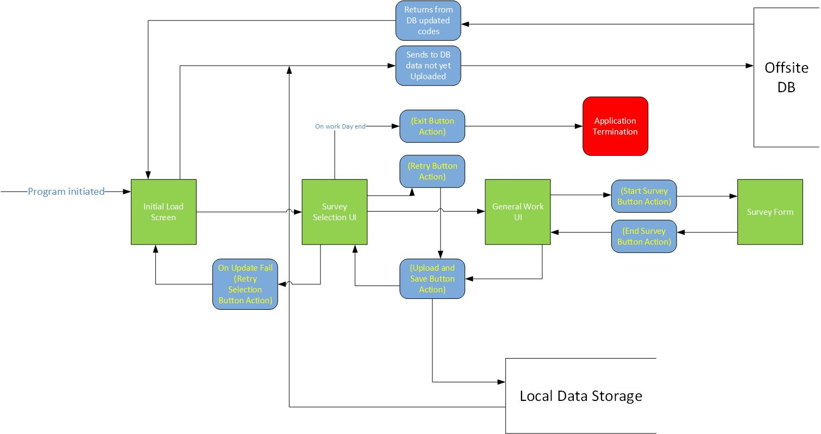
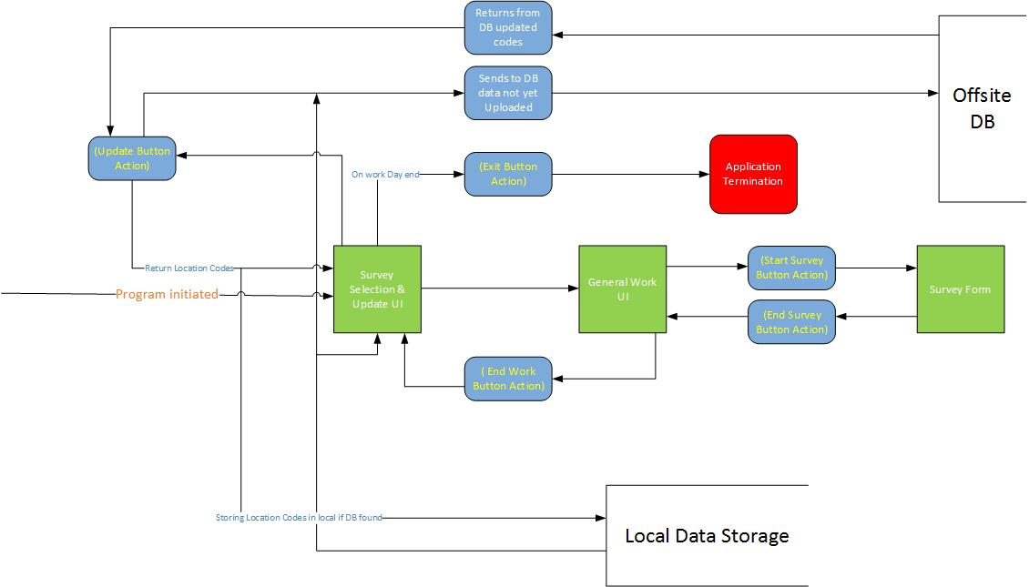

Product Features
The Creel Input System features all fields that appear on the paper Franklin D. Roosevelt Lake Creel Survey Form. Users can fill out the form by selecting the angler answer from drop down menus or enter information via the onscreen keyboard.

[1] The application will sync with the database updating various codes i.e. [location, fish…]

[2] The application will upload survey data to database

User Classes and Characteristics
Creel Clerk (favored)

A Creel Clerk is the user who interviews anglers and records the answers in the Creel Input System. All Creel Clerks have been trained how to do a creel survey. Creel Clerks possess a varying range of technical expertise, some may need basic computer skill training.

Operating Environment (OE)
OE-1: The Creel Input System shall operate on the following operating system: Windows 7
Professional (64 bit).
OE-2: The Creel Input System shall operate on the following hardware platform: Getac Tablet (Model F110).
OE-3: The Creel Input System shall be fully compatible with the Fish Survey Database.

Design and Implementation Constraints (CO)
CO-1: The Fish Survey Database must be used.
CO-2: The Creel Input System must use JSON to communicate with the Fish Survey Database.
CO-3: All code must be written in a language that allows for modification and upgrades.

User Documentation (UD)
UD-1: The team will demonstrate the software to the client upon completion.
UD-2: The team will create help files for the software.
UD-3: The client will be responsible for training the Creel Clerks on use of the system.

Assumptions and Dependencies (DE)
DE-1: The Creel Input System depends on the Fish Survey Database being implemented in the manner described by Team 4.

System Features

Welcome Screen User Interface
3.1.1 Description and Priority
An options menu is displayed. Priority: High

3.1.2 Stimulus/Response Sequences
Stimulus: A Creel Clerk selects the "Creel Survey". [Optional]Raw fish and FWIN
Response: The application launches the survey.
Stimulus: A Creel Clerk selects "upload/update".
Response: The application follows the upload/update procedures. (See 3.4 and 3.5)
3.1.3 Functional Requirements (REQ)
REQ-1: Creel Survey User Interface

General Work Information Entry User Interface
3.2.1 Description and Priority
A Creel Clerk enters general work information. Priority: High
3.2.2 Stimulus/Response Sequences
Stimulus: A Creel Clerk enters their initials, selects the survey type and section, and presses "start day".
Response: Information is saved in internal memory log files. Creel Clerk is given the option to add a location.

Stimulus: A Creel Clerk clicks "end" upon ending work.
Response: Ending work time is saved in internal memory log files. Welcome screen is displayed.

3.2.3 Functional Requirements (REQ)
REQ-1: Internal Log Files

Angler Creel Survey Entry User Interface
3.3.1 Description and Priority
A Creel Clerk completes an angler creel survey. Priority: High
3.3.2 Stimulus/Response Sequences
Stimulus: A Creel Clerk selected bus route.
Response: Location time will count down and prompt the clerk to leave the location when time is up.
Stimulus: A Creel Clerk will enter angler party information. (See Appendix B, UI-3.1)
Response: Information is saved in internal memory log files.
Stimulus: A Creel Clerk clicks the "add fish" button.
Response: A new fish line is added to the screen with the fields, species caught and kept/released. (See Appendix B, UI-3.3)
Stimulus: A Creel Clerk marks the fish as kept.
Response: The fish details fields are added to the fish line. (See Appendix B, UI- 3.4 and UI-3.5)
Stimulus: A Creel Clerk marks the fish as released.
Response: The total field is added to the fish line. (See Appendix B, UI-3.6)
Stimulus: A Creel Clerk clicks the "add party" button.
Response: Information is stored in internal memory log files and the fields are cleared. Previous parties are accessible via arrow buttons.
Stimulus: A Creel Clerk clicks the "end location" button.
Response: The system returns to the general work information entry screen. A summary of the location is displayed.
3.3.3 Functional Requirements (REQ)
REQ-1: Internal Log Files
REQ-2: Internal Log File naming convention
“Initials-SurveyType-TimeDate-Fail/Success”
REQ-3: Movement between views with various selections
REQ-4: Entry responses informing user of result

Upload Data to the Fish Survey Database
3.4.1 Description and Priority

The Creel Clerk submits the data they collected via JSON object to the Fish Survey Database. Priority: High
3.4.2 Stimulus/Response Sequences
Stimulus: The Creel Clerk chooses to upload the data.
Response: The Creel Input System attempts to connect to the Fish Survey Database. If a connection is made within 5 minutes the Creel Clerk is prompted for their username and password. Otherwise the Creel Clerk is prompted to either try the connection again or skip it. If the upload fails to complete in 5 minutes the connection times out.
Stimulus: Username or password fail validation by the Fish Survey Database.
Response: The Creel Clerk is informed of the error and prompted to try again.
Stimulus: Username and password are validated by the Fish Survey Database.
Response: Data transfer begins.
Stimulus: Data uploads to the Fish Survey Database.
Response: The Creel Clerk is informed of the success.
Stimulus: Data fails to upload to the Fish Survey Database.
Response: The Creel Clerk is informed of the failure and is prompted to try again or exit.
3.4.3 Functional Requirements (REQ)
REQ-1: Internet Connection
REQ-2: Fish Survey Database

Download Data From the Fish Survey Database
3.5.1 Description and Priority
Updates from the Fish Survey Database are received in JSON object format and applied to the application's fields.

3.5.2 Stimulus/Response Sequences

Stimulus: The Creel Clerk chooses to update the system.
Response: The Creel Input System attempts to connect to the Fish Survey Database. If a connection is made within 5 minutes the data transfer begins. Otherwise the Creel Clerk is prompted to either try the connection again or skip it. If the download fails to complete in 5 minutes, the connection times out.
Stimulus: Data downloads from the Fish Survey Database and the updates are applied.
Response: The Creel Clerk is informed of the success.
Stimulus: Data fails to download from the Fish Survey Database.
Response: The Creel Clerk is informed of the failure and is prompted to try again or skip it.
3.5.3 Functional Requirements (REQ)
REQ-1: Internet Connection
REQ-2: Fish Survey Database

External Interface Requirements

User Interfaces (UI)
The user interface will be split into 3 different views.(See Appendix B and C)
UI-1: Initial view will be a welcome screen that will provide choices for surveys and updating/uploading. If updating/uploading is selected the user will be presented with a progress indicator. (TBD)
UI-2: The general work entry information view will collect information about the general workday. Users will be able to add a new location from this view. A day summary will appear on this screen as the day progresses. (See Appendix B, 2.1 and 2.2)
UI-3: The angler creel survey entry view will collect information about the angler party being interviewed. Users will be able to add fish, view previous parties, add another party, and end the location. If the survey is a bus type the application will prompt the user when time is up at the location. (See Appendix B, 3.1 and 3.2)

Hardware Interfaces (HI)
HI-1: Getac Tablet running Windows 7 (64bit)
HI-2: Touch screen using a virtual keyboard
HI-3: Stylus
HI-4: Web based Server (ASP.Net) running MySQL (Fish Survey Database)

Software Interfaces (SI)
SI-1: Windows 7 (64 bit) installed on Getac (Connected via Windows Libraries on C#)
SI-2: Offsite MySQL server (ASP.Net) where the database is stored (Connected via JSON Package Transfers)

Communications Interfaces (CI)
CI-1: Be able to package up data into a JSON object and send it to a web server
CI-2: Be able to unpack a JSON object to update local data from the web server
CI-3: Be able to reinitialize any unsuccessful data back into the application and attempt to repackage and retry upload

Other Nonfunctional Requirements

Performance Requirements
Our system does essentially no heavy processing so the application should run at an extremely fast rate where once the user submits data they should be immediately greeted with the appropriate screen. The only exception would be when sending data to the DB, which is reliant on Internet connectivity.

Security Requirements (SR)
SR-1: Username and password will be entered on the client side
SR-2: Username and password will be verified on the server side
SR-3: Client side will display pass/fail of credentials and allow/deny upload

Software Quality Attributes
Reliability: The application must be extremely reliable, working 100% of the time, so unit and field testing will have to be done to ensure this.
Correctness: Additionally the application must be able to interact appropriately with the Fish Survey Database and submit data correctly.
Maintainability: The software must be able to be updated as the list of fish species, locations, etc. changes.
Usability: The interface must be intuitive, easy, and quick to use.

Other Requirements (R)
R-1: Testing and documentation of testing should be done to ensure the reliability of the product.
R-2: Additionally the client will need full documentation on how to run the application, upgrades and/or maintenance.

Final Deliverables (D)
D-1: A Creel Input System executable for use on Getac tablets.
D-2: A copy of all source code.
D-3: A demonstration of the system.
D-4: Email addresses for all team members to be used by maintenance/upgrade programmers.
Appendix A: Glossary
[Access Type] – Creel clerk conducts creel surveys in one location all day.

[Angler] – Fisherman

[Bus Route Type] – Creel clerk proceeds along a predefined route, arrives at each location on a precise schedule, conducts creel surveys at a site for a defined period of time, then proceeds to the next site along the route.

[Creel Survey] – An interview where the surveyor asks fishermen questions regarding their fishing activities and records their responses.

Appendix B: User Interfaces
UI-1: Proposed Welcome Screen
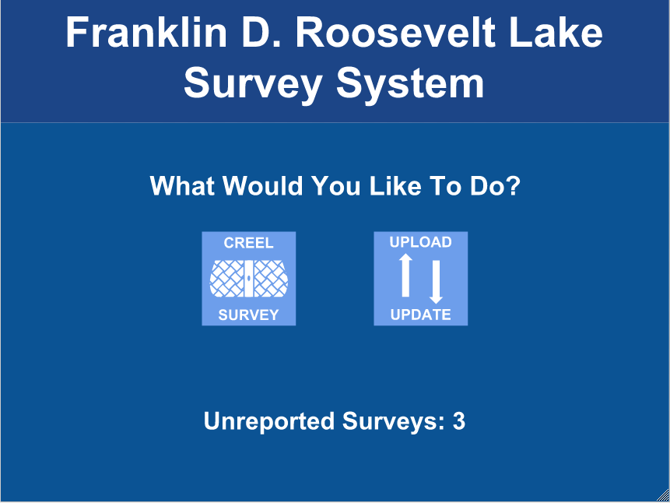

UI-2.1: Proposed General Work Information Screen
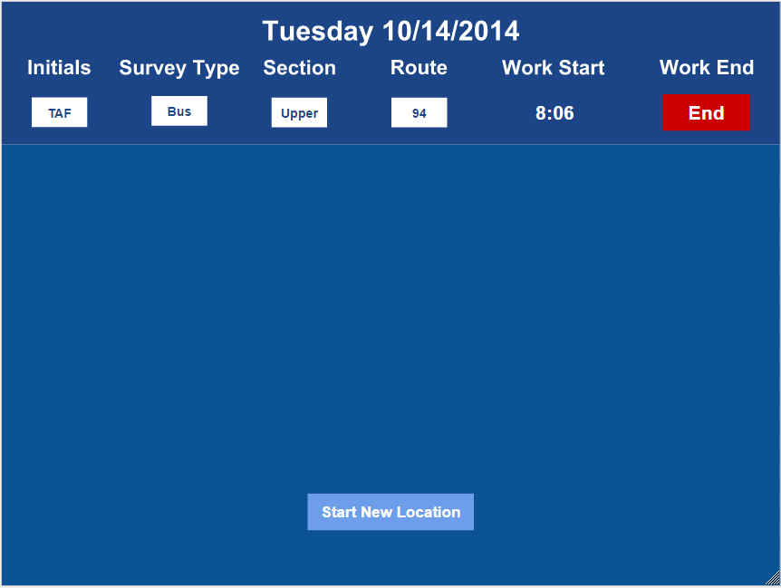

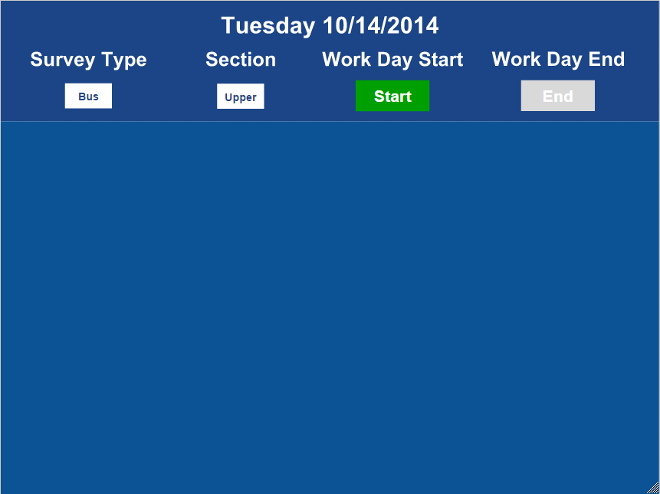

UI-2.2: Proposed General Work Information Screen with Day Summary

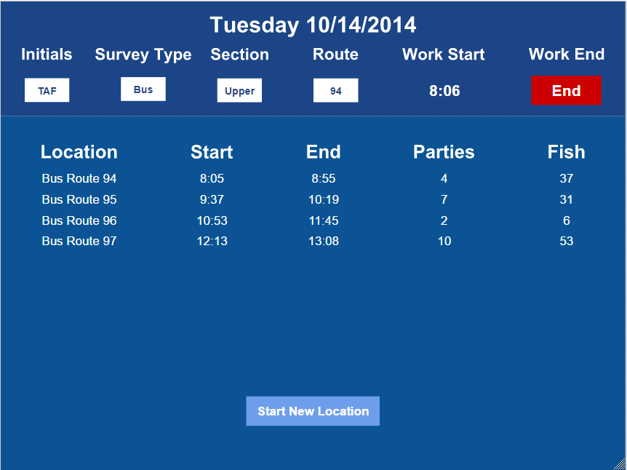

UI-3.1: Proposed Angler Creel Survey Entry Screen
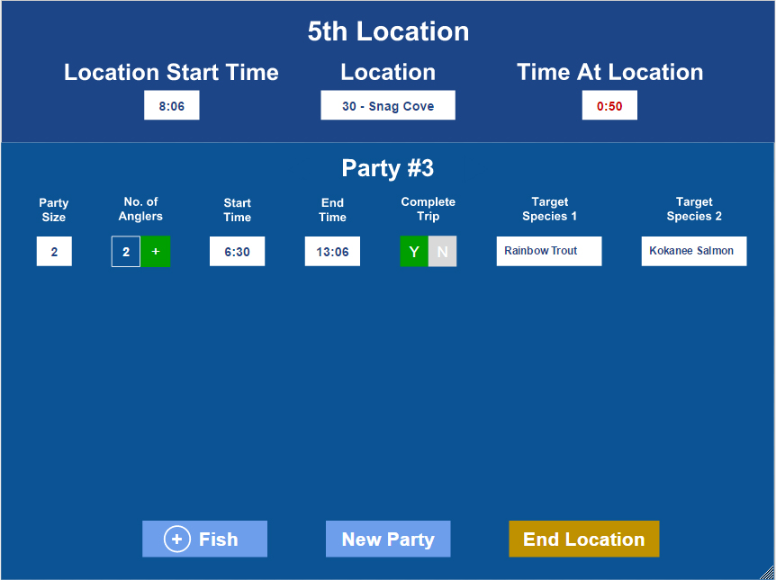

UI-3.2: Proposed Angler Creel Survey Entry with Bus Route Timer Screen
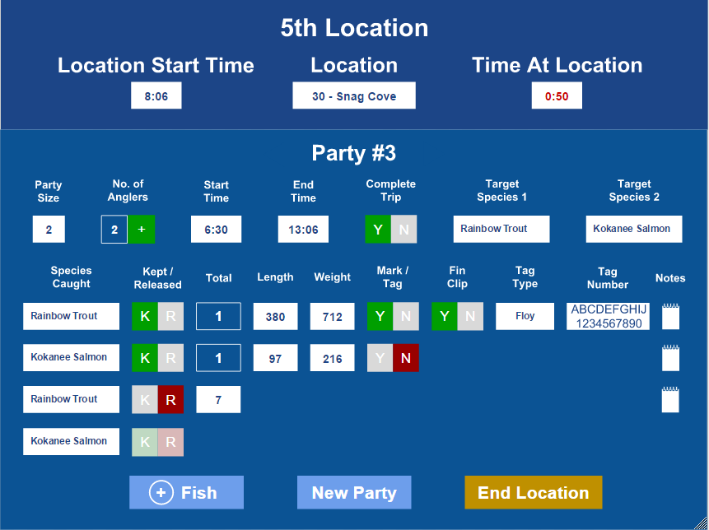
UI-3.3: Proposed Fish Line with Species and Kept/Released

UI-3.4: Proposed Fish Line, Fish Kept with Tag Info
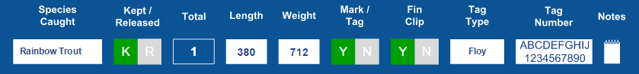

UI-3.5: Proposed Fish Line, Fish Kept Without Tag
UI-3.6: Proposed Fish Line, Fish Released


Appendix C: User Stories
US-1: Proposed Welcome Screen User Stories

The user will begin the program exclusively with one of two goals. They will either be within a Wifi location with the intent to upload their surveys, or they will be on location with the intent to complete a day’s survey.

The active controls and labels on the screen will work as follows:

- The [CREEL SURVEY] button will exit the startup screen and launch the day summary page for the creel survey.
- The [UPLOAD UPDATE] button will do the following when clicked:
  - Attempt to make a connection database web applications. Once a connection is made, the system will update location and fish variables to match the database, and it will upload each day’s survey to the database.
  - Place an undetermined waiting animation somewhere in the center of the screen while the process completes.
  - Disable all buttons on the screen while the process completes.
- The Unreported Surveys label will display the count of surveys that have not yet successfully been uploaded to the database. Thus the number on this label will be incremented with each new survey, and it will be reset to zero every time all surveys have been uploaded.

US-2: Proposed General Work Information Screen User Stories
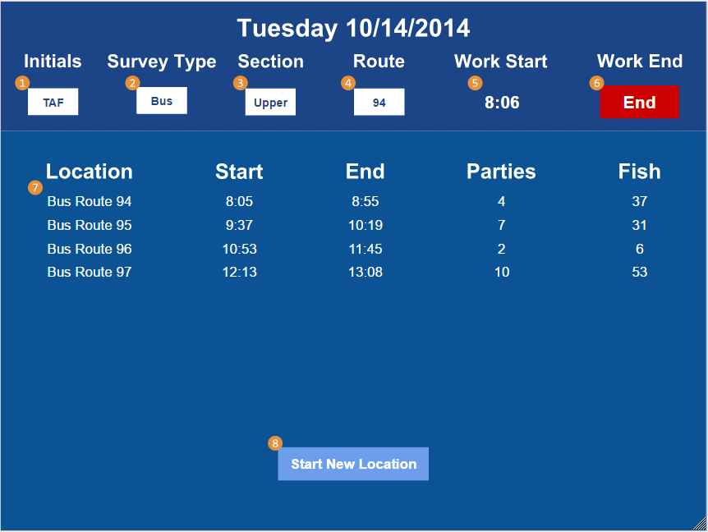
Upper Portion - The first three controls from the left will be the only controls active on the page when the page is first loaded as a new survey. The controls in this section will work as follows
- Initials - When the user click on this box to enter their initials, an onscreen keyboard will appear to allow the user to easily type their initials.
- Survey Type - This will be a dropdown that allows either the choice of either a Bus or Access type.
- Section - Dropdown that allow the choice from Upper, Middle, and lower sections.
- Route - This dropdown menu will only be active if the user selected the survey as a Bus type.
- Work Start - Once the previous controls on this line have been entered, this green button will be made active. When the user clicks on the button, the following will happen:
  - The button will turn into a time stamp on the UI that shows when the day started.
  - The [Work End] button will be activated.
  - The [Start New Location] button will also be activated.
- Work End - This button will turn into a timestamp of when it was clicked
Lower Portion - This section will be inactive until the day has started.
7. Survey Summary Section - This area will print all locations the clerk has already surveyed.
8. Start New Location - This button will take you to the location survey screen when it is pressed. When the work day is over, this button will turn into a [Return To Main Screen] button that will take you back to the main page.

US-3: Proposed Angler Creel Survey Entry Screen User Stories
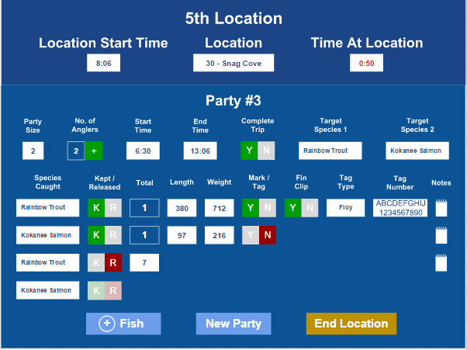
Upper Portion - This section displays the metadata for the current survey location. This data includes:
- The current survey location index for the day.
- The start time for the location.
- The location code and name. This will be a drop down in which the user must select a location before the lower portion is enabled.
- The time the clerk has been at the current location.
Lower Portion - This section will present all the controls for the group and fish data entry.

Party Data Entry Line - The input methods of the controls fit into the following categories:

- Numerical Text Entry - Party Size, Start Time, End Time, and Zip Code.
- Y | N Toggle Control (Yes/No) - Completed Trip.
- Alphanumeric Text Entry - Target Species 1 and Target Species 2.
- Special - No. of Anglers. Pressing the [+] button on this control will cause a small pop-up control to appear that will disable all controls, and it will present the clerk with the ability to add anglers to the group by entering a angler type and zip code for each angler.

Fish Data Entry Lines - When a new fish line is created, the clerk will be presented with a drop down to select the fish type and whether the angler kept the fish or released it. The visibility of the other controls depend on this second decision.

- Kept Fish
  - The total number of fish will automatically be selected as a single kept fish. This number will not be editable by the clerk.
  - The clerk will also be required to enter data into the numerical text fields of fish weight and length.
  - The clerk will also have to select whether there is a Mark or Tag on the fish. The visibility of the remaining controls are determined on the selection.
    - Yes, there is a Mark or Tag present. The user will then be required to fill the following fields.
      - Indicate whether a Fin Clip is present using a toggle switch
      - Select a Tag Type using the corresponding drop down
      - Enter is an alphanumeric Tag Number
    - No, there is no Mark or Tag present. No other controls will be presented on this line.
- Released Fish
  - The clerk must then enter in the total number of fish of the selected species were released using an numeric keypad that will be displayed on the screen.
  - No other controls will be presented on this line.

Lower Buttons - These buttons will accomplish and be enabled as follows:

- [(+) Fish] Button
  - This button will only be enabled when there is no incomplete fish or party line.
  - When clicked, this button will add a new fish data entry line and disable itself until the above condition is re-met.
- [New Party] Button
  - This button will only be enabled when there is no incomplete party line.
  - When clicked, this will clear any data in incomplete fish lines on the current page, and save all completed fish lines in relation to the party information. It will then clear the fish and party lines so a new fishing party can be entered.
- [End Location] Button
  - This button will always be enabled.
  - When clicked, this will save all party information as objects inside the location object, and it will return to screen 2, the general work with day summary page.

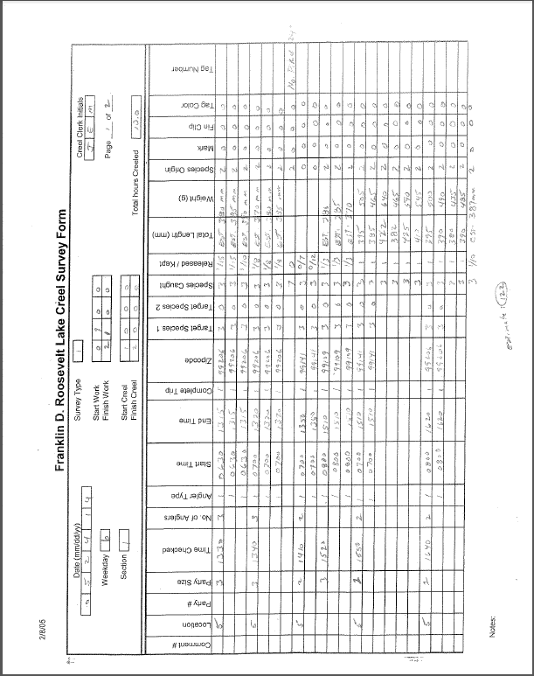
Appendix D: Legacy Forms
Appendix E: Proposed Timeline and Distribution of Work

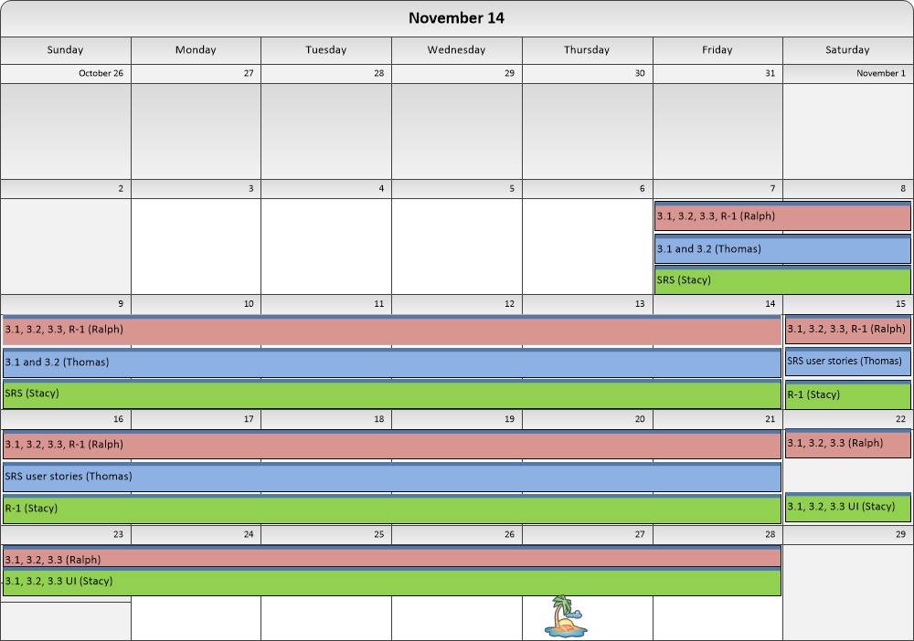
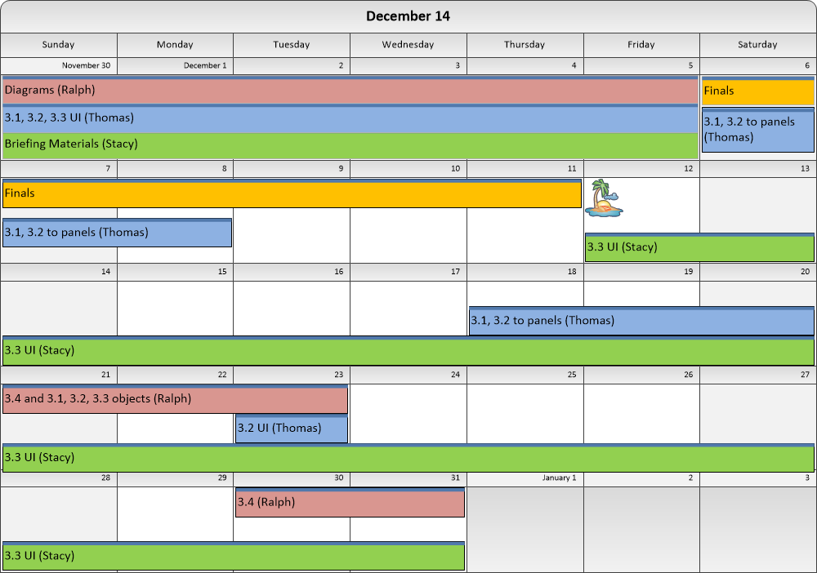
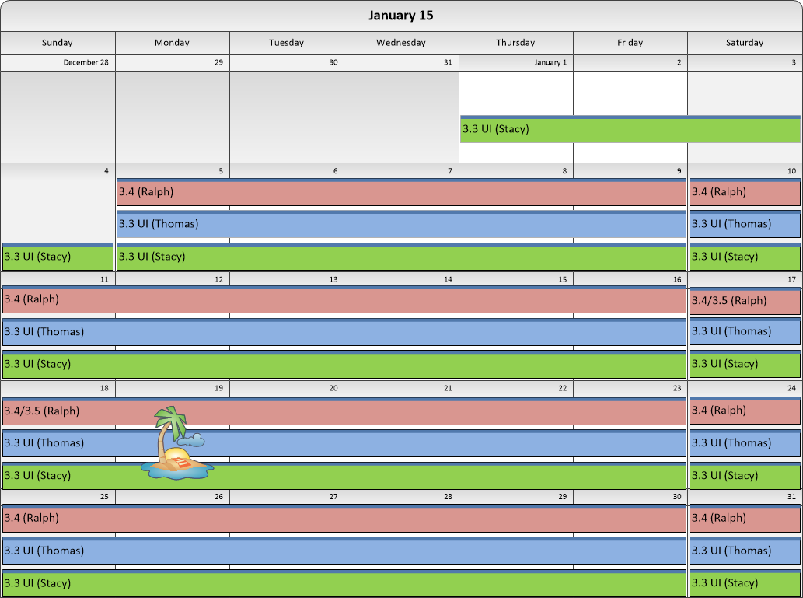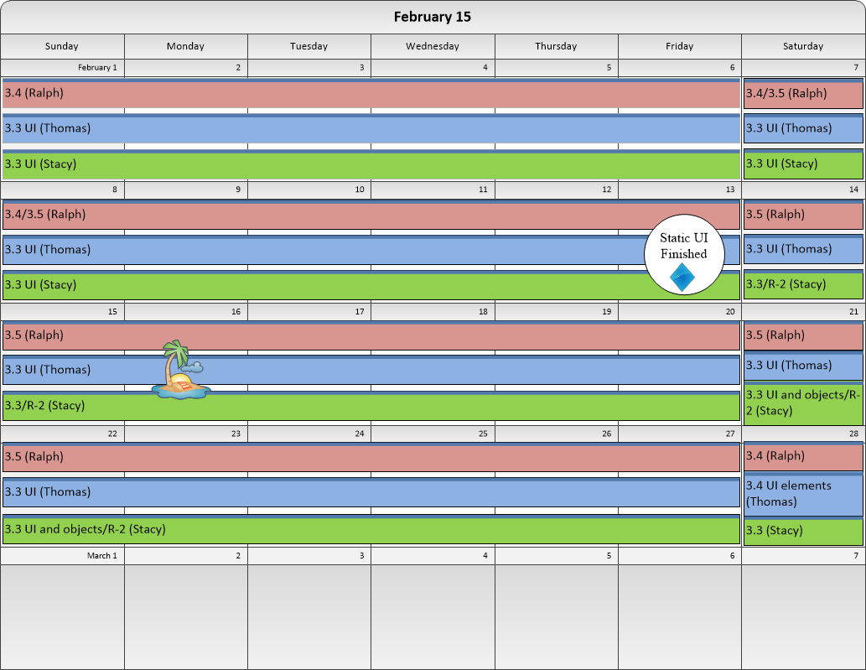

Appendix F: Issues List

- (DB Schema)TBD

